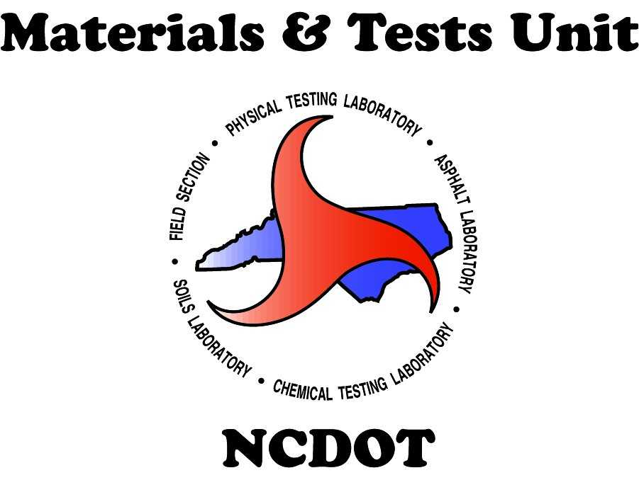

Standard Operating Procedure
2025 Ready-Mix Concrete Facility Annual Audit

Objectives:

- The purpose of the Annual Facility Audit is to verify that Ready-Mix Concrete facilities are operating in compliance with NCDOT standards and properly documenting their processes. These audits ensure the facilities are capable of producing NCDOT-approved concrete.
- Audits shall be conducted at least once per calendar year, unannounced, and are recommended during periods of NCDOT concrete production.
- Facilities that fail to pass the Annual Facility Audit by the end of the calendar year, without a significant reason, may be removed from the NCDOT “Approved Facilities List”.

Materials Inspection and Acceptance:

The review of all proper documentation and the collection of materials samples will verify that the facility meets all NCDOT standards and complies with all NCDOT Materials and Tests Unit policies.

Safety Concerns:

Personnel should always remain aware of the operation of equipment and machinery. They should review and adhere to all safety guidelines established by the facility.

M&T Inspector’s Audit:

- Review and verify the original or a copy of the 3rd party facility certificate to ensure it is active, signed, and available on-site. Record the certificate’s expiration date on the Annual Audit Checklist.
- Review and verify the original or a copy of the most recent 3rd party inspection report. A copy of the completed report conducted by the 3rd party must be available on-site. Record the inspection date on the Annual Audit Checklist. The inspection date must not be older than 24 months.
- Verify whether the facility management has submitted all most current 3rd party inspection documentation to M&T. The email should be sent to readymixinspections@ncdot.gov.
- Review and verify whether the facility is utilizing approved truck mixers or agitators. Note: inspections of the mixers and/or agitators must be conducted annually, and a copy of the report should be kept on-site. Record the inspection expiration date on the checklist form. Verify whether facility management has submitted the most current Fleet report to readymixinspections@ncdot.gov.
- Review and verify the certification of all on-site NCDOT-certified Concrete Field Technicians, if applicable. Ensure that the technician’s certifications are active. List all names and required certification information in the table on the second page of the Audit Checklist. If marked as “N/A”, provide an explanation in the Comments.
- Review and verify the certification of all on-site NCDOT-certified Concrete Batch Technicians. Ensure that technician’s certifications are active. List all names and required certification information in the table on the second page of the Audit Checklist. If marked as “N/A”, provide an explanation in the Comments.
- Review and verify that the facility is utilizing NCDOT-approved mix designs. Hard copies must be available on-site. If marked as “N/A”, provide an explanation in the Comments.
- Review and verify that the facility is utilizing approved materials (such as cement, fly ash, slag, aggregate, water, and admixtures, etc.) in accordance with the approved mix designs, ensuring conformity with the actual BOL for received materials.
- Verify the calibration reports for the scales, including the actual stickers with dates, and for smaller scales using in moisture tests. Scales must be calibrated at least semiannually.
- Verify on-site whether the certified Batching Technician can perform moisture tests on Fine and Coarse aggregates, including the calculations. Verify the documentation related to the performance of moisture tests on fine and coarse aggregates, such as Form 250. Ensure that the moisture test equipment is in good and working condition.
- Verify on-site that the certified Batching Technician has the ability to adjust moisture during the batching process. Review whether the batch tickets and/or operating process are acceptable.
- Verify on-site to ensure that the certified Batching Technician periodically performs the correlation of the moisture probe with actual moisture, if applicable, and has the ability to adjust moisture probe, if needed. If marked as “N/A” provide an explanation in the Comments.
- Review the associated NCDOT documentation on-site, such as Form 903, Form 250, copies of batch weights tickets, etc., and verify that all these documents are fully completed for every NCDOT production of concrete. If marked as “N/A”, provide an explanation in the Comments.
- Verify that the current Admixture calibration report is on-site. Record the inspection date on the Audit Checklist form. Note: The admixture must be calibrated at least semiannually.
- Verify that the annual water test report is on-site. Note: Ready-Mix Concrete facilities must conduct the water test at least once per year. If marked as “N/A”, provide an explanation in the Comments.
- Sample the water from the facility. Note: If the water sample was taken by the M&T inspector during the audit, the M&T inspector shall provide a copy of that test report to the plant manager after obtaining the test results.

Required Sampling:

Top of the second page: M&T Inspector shall indicate if all materials for the concrete at the plant match BOL and all approved Mix designs.
- Cement – one gallon (plastic bag). Sample from the plant discharge end (not from the “test” bags).
- Fly Ash (or Slag) – one gallon (plastic bag). Sample from the plant discharge end (not from the “test” bags).
- Fine Aggregate – one bag (8 – 10 pounds). Sample from stockpiles or from the conveyor belt.
- Coarse Aggregate – #57 and #67 one bag (20 – 30 pounds); #78M one bag (10 – 15 pounds). Sample from stockpiles or from the conveyor belt.
- Water – ½ gallon (one wide mouth jar). Water shall be tested once per calendar year during annual audit and shall be obtained from the pipe that will feed water into the mixer.
- If using Well water, it shall be tested for 100% of facilities using this type of water for the concrete mixes.
- If using Public water, a sample is required only in the following counties: Beaufort, Bertie, Brunswick, Camden, Carteret, Chowan, Craven, Currituck, Dare, Gates, Hyde, New Hanover, Onslow, Pamlico, Pasquotank, Pender, Perquimans, Tyrell and Washington shall be tested a minimum of once per calendar year.
- For all Out-of-state facilities water shall be sampled and tested regardless of sources.
After receiving tests results of water, a copy of these records must be provided to the plant.
Samples should be submitted to Chemical and Physical Laboratories with appropriate sample cards. In a sample card for water shall be indicated: a) sources of water: Well or City; b) County; c) If it’s a new facility for NCDOT.

Sample Prep and Submittal:

Sample containers shall be handled to avoid contamination during the sampling, log-in, and transportation process.
Sample cards shall be fixed to their corresponding sample container and transported to the appropriate laboratory for analysis.
Samples shall be entered utilizing the HiCAMS system - see Annual Facility Audit Field Manual for entry examples.
HiCAMS # for samples shall be provided in the Audit Checklist.

Documentation Submittal:

The completed (fill-in-the-blanks) “Ready-Mix Concrete Annual Facility Audit Checklist” shall be submitted as Word document to the email: ReadyMixInspections@ncdot.gov . This document shall be submitted electronically.

